

**MyWCOnline**

**Instruction Manual**

**2024-2025**

Table of Contents

**Log In**

Log in to MyWCOnline

Log out of MyWCOnline

Access the Writing Center section of MyWCOnline

**Managing Appointments**

Schedule an Appointment

Join an Existing Online Appointment

Cancel an Appointment

**Log In After WCOnline Registration**

1. Log into <https://loyola.mywconline.com/>

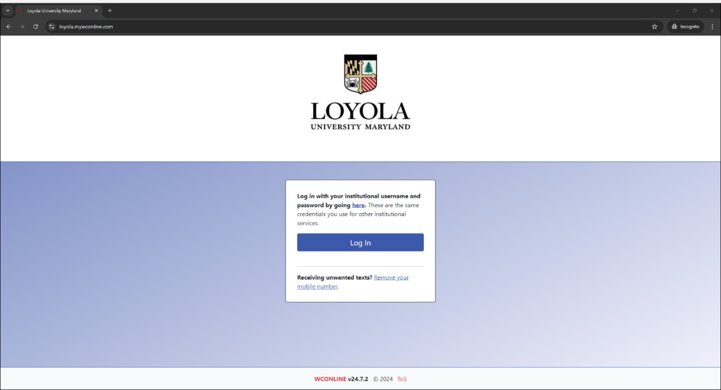

**Log Out**

1. Select “Log Out” in the upmost menu bar
   1. Note: This upmost menu bar and “log out” option is also accessible on other pages of MyWCOnline

**Access the Writing Center**

1. Log into <https://loyola.mywconline.com/>
2. Select Undergraduate or Graduate Under “Writing Center”

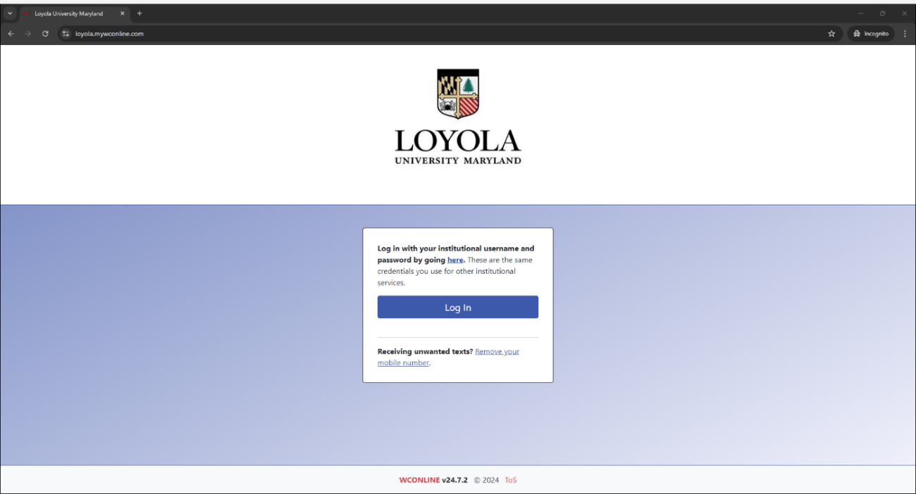 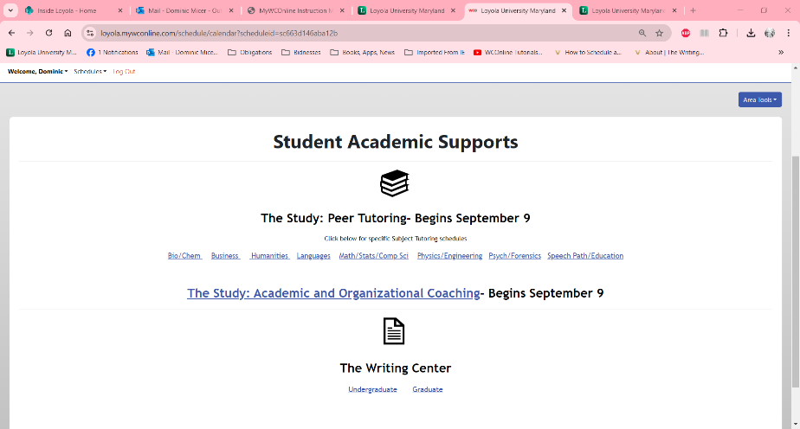

(Step A) (Step B)

**Schedule an Appointment**

1. Log into <https://loyola.mywconline.com/>
2. Select “Schedules” in the center of the screen, then “Undergraduate Writing Consulting Fall 24” in the drop box
3. In the white “Display Options” menu box, use the two options to filter your results.
   1. To filter what staff and resources appear, go to the left box.
   2. To filter what type of meeting options appear, online or in-person, go to the right box.
4. Select the box that corresponds to the preferred date, tutor, and time
   1. Note: for more date options, select the calendar icon directly above the “Display Options” menu box
   2. Note: once you select a white box, a new window will open
5. In the new window:
   1. Select the preferred end-time of the meetings
   2. Select whether the meeting will be online or in-person
   3. Type in the course that the meeting will address, the professor of that course, and what topics you wish to address
      1. [Optional] Attach 1-3 PDF or Word files. (Such files could include the directions of an assignment, a draft, an outline, etc.) The tutor will be able to see the attached file. During online meetings, the tutee and tutor will be able to see the file as a live shared document.
6. Select the blue “Create Appointment” button at the bottom of the window
   1. Ensure that you received an email verifying that your appointment has been made.

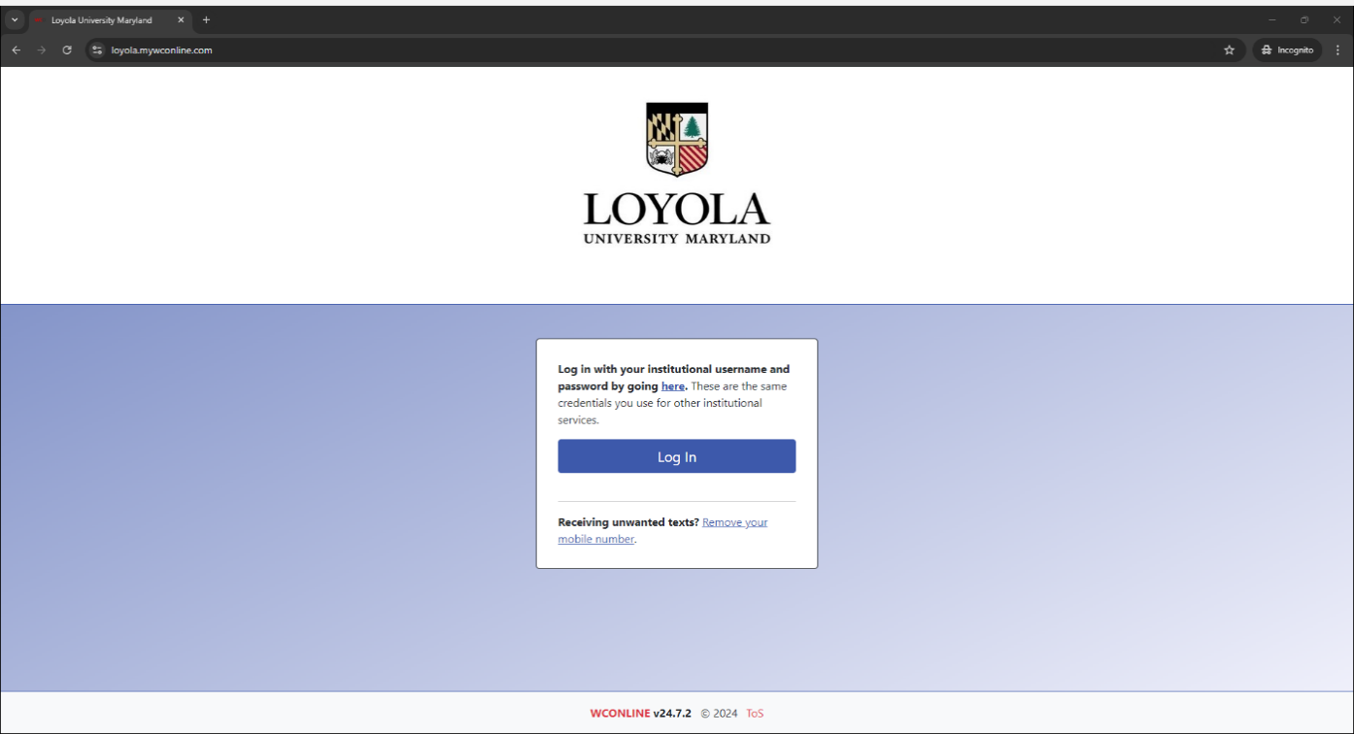 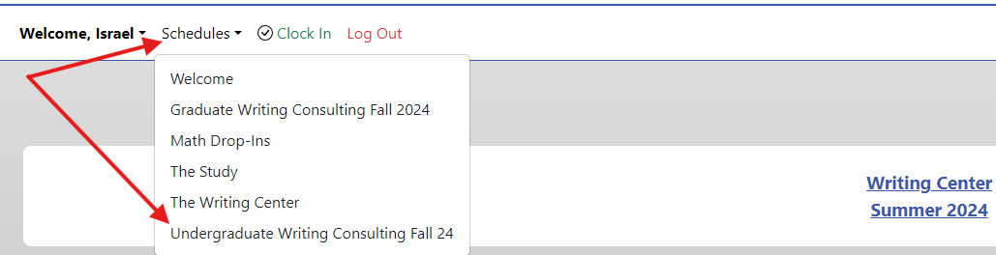(Step A) (Step B)

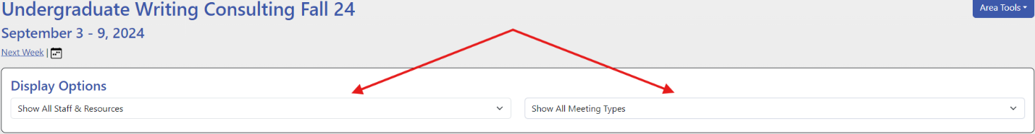(Step C)

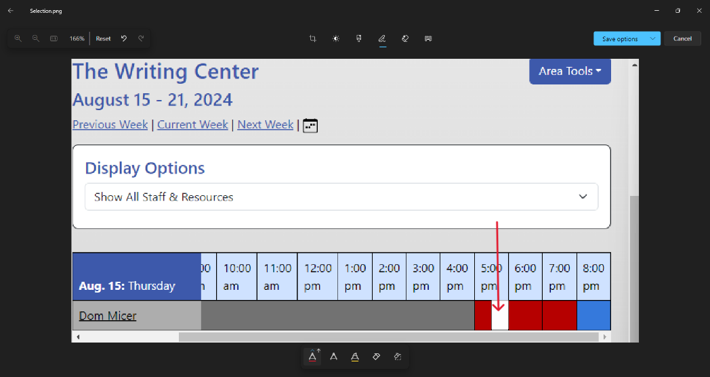

(Step D)

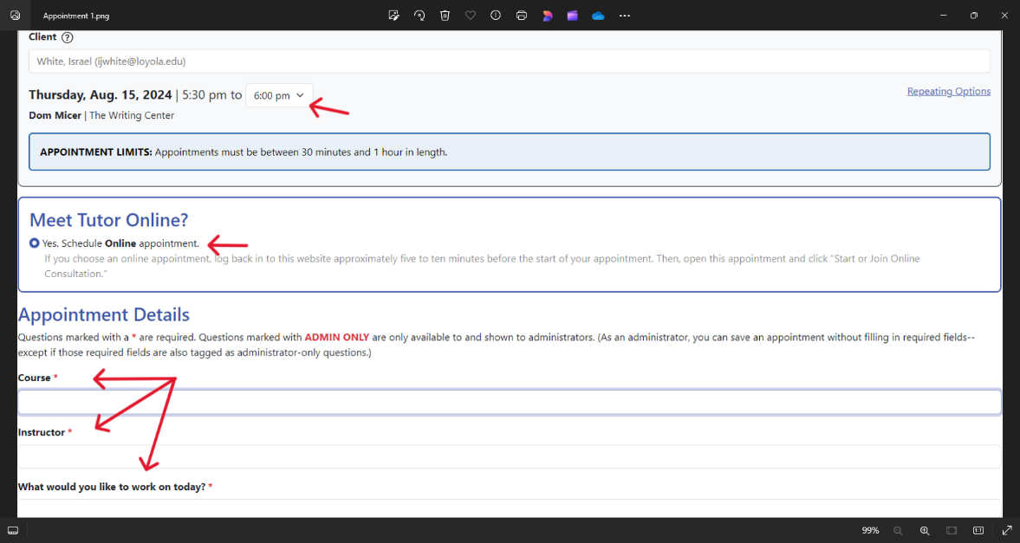 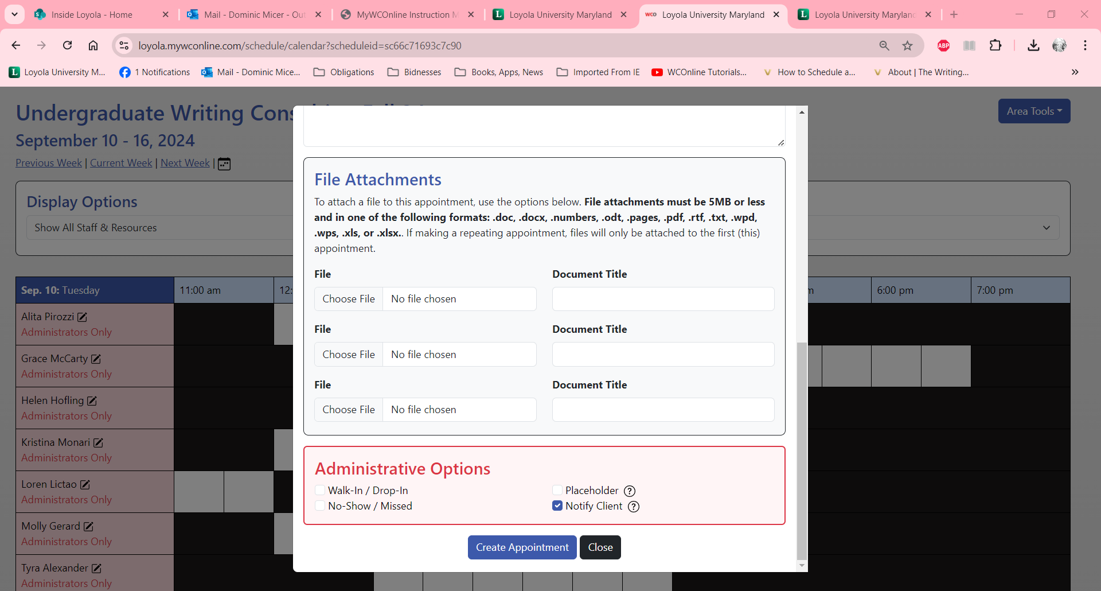

(Step E) (Step F)

**Join an Online Appointment (For Grad Students)**

1. Log into <https://loyola.mywconline.com/>
2. Select “My Appointments” in the upmost menu bar
   1. Select the drop box option that corresponds to the preferred date, tutor, and time
      1. Note: a new window will then open
3. Select the red box that reads “Start or Join Consultation” in the new window
   1. Note: a new window may then open
4. Select the blue box that reads “Start or Join Consultation” button in the new window

 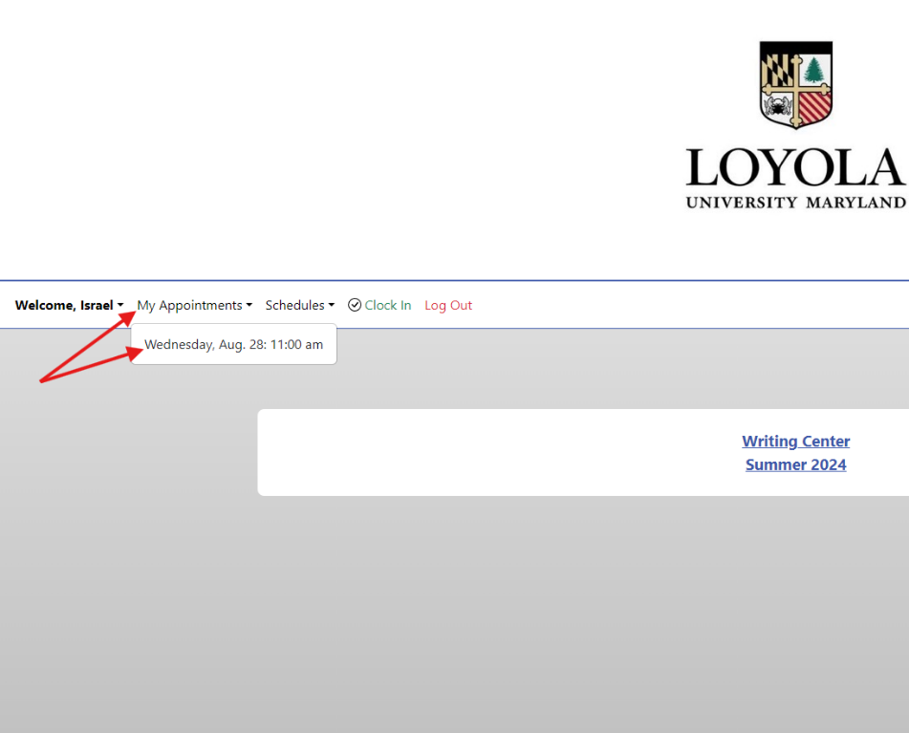

(Step A) (Step B)

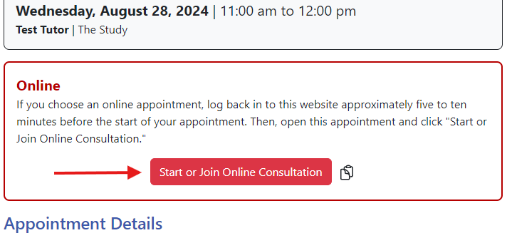 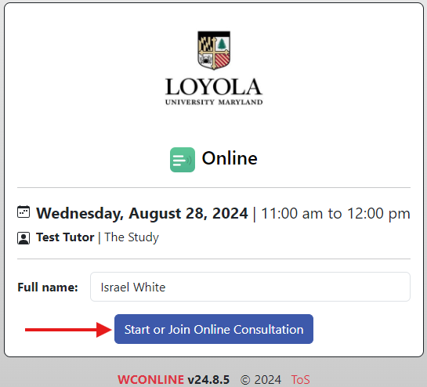

(Step C)  (Step D)

**Cancel an Appointment**

1. Log into <https://loyola.mywconline.com/>
2. Select “My Appointments” in the upmost menu bar
   1. Select the drop box option that corresponds to the preferred date, tutor, and time
      1. Note: a new window will then open
3. Select the red “Cancel Appointment” button at the bottom of the new window
   1. Note: a new window will then open
4. Select the red “Confirm Cancelation” button at the bottom of the new window

 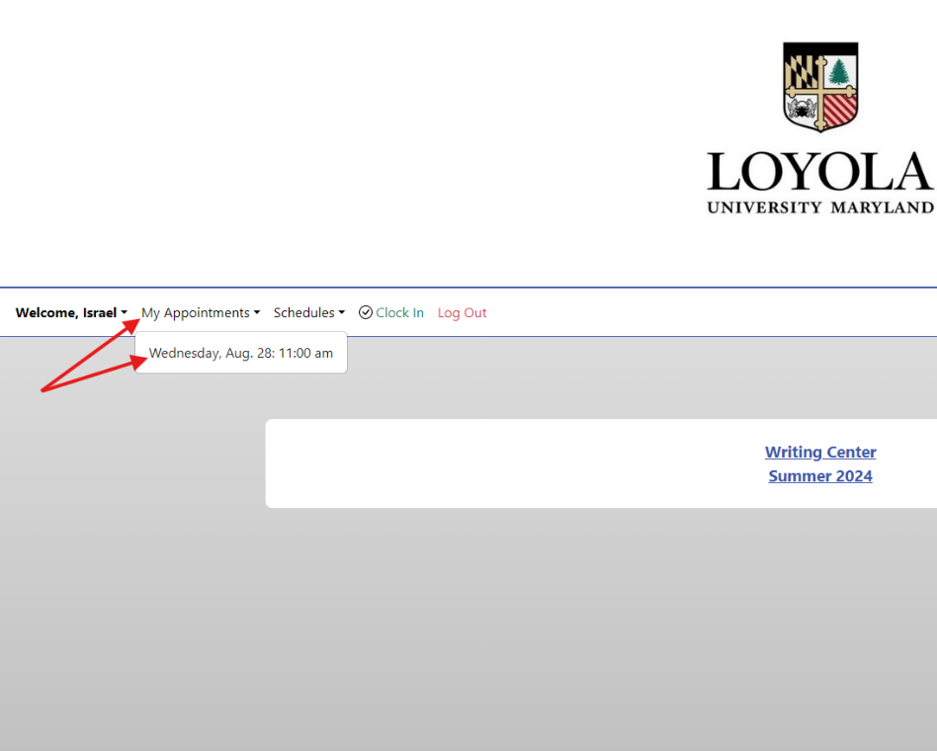

(Step A) (Step B)

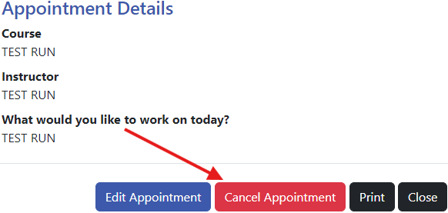 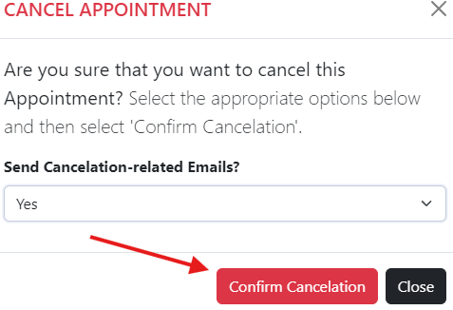

(Step C) (Step D)