WCOnline Account Setup & Log-in

Welcome to Loyola University Maryland Writing Center Graduate Summer Tutoring

This section will go through how to set up an account on WCOnline and Log in after account setup.

# General WCOnline Tips

1. In many places throughout the WCOnline site, you will see a small blue bubble with a question mark:  When you see this, you can hover your mouse over the bubble to get more information about that particular feature or option.
2. WCOnline can be used on a computer browser or on a mobile device. On your computer, WCOnline works best with Google Chrome and Mozilla Firefox. More information about phones, soon.

# Account Set-up

1. Navigate to <https://loyola.mywconline.com/>. Please bookmark this page for future ease of access.
2. For your first login, choose the “Log in with your institutional username and password by going here” link:

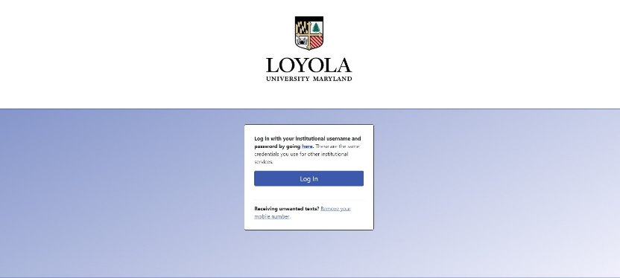

1. Fill in all of the necessary elements on the form labeled with a red asterisk:

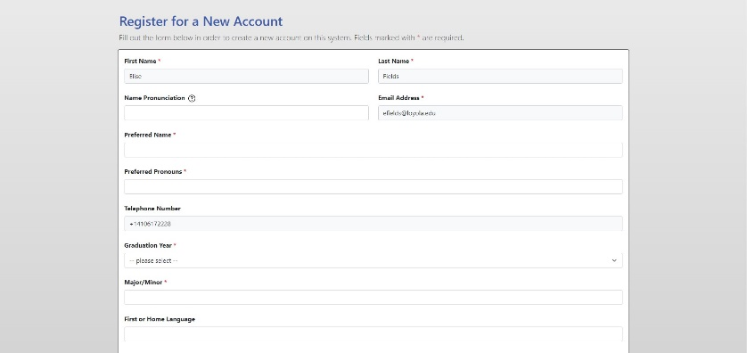

1. At the bottom of the screen, choose your communications preferences (for example, if you only want to receive email reminders of appointments, do nothing; if you want text message reminders, put in your details).

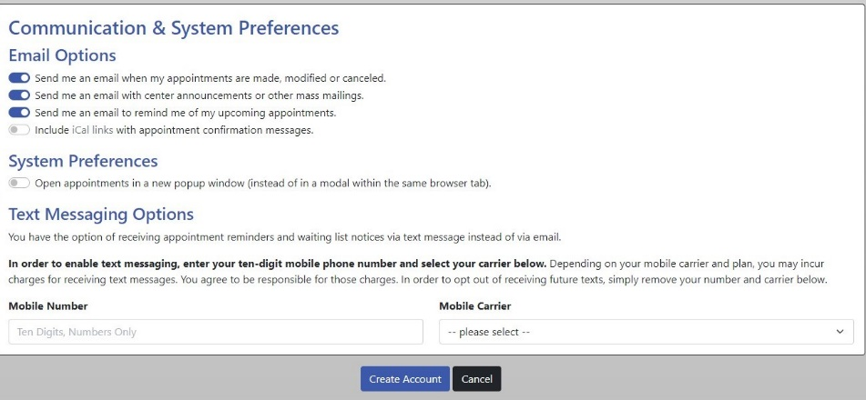

1. Click the Create Account button to finish creating your WCOnline Account.