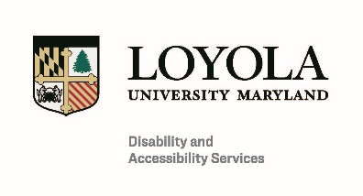

Documentation Guidelines for Students Requesting Accommodations Due to a Learning Disability
Disability and Accessibility Services (DAS) coordinates an interactive process to determine reasonable accommodations for students with disabilities at Loyola University Maryland. We request documentation to gain input and recommendations from educational, medical, and mental health professionals who have current knowledge of the student’s disability-related needs. We encourage professionals providing documentation to work directly with the student to determine what specific accommodations the student needs to achieve equal access in the university environment.
Documentation is just one part of the assessment of what accommodations are necessary and effective for a student. Documentation alone does not determine whether accommodations are approved or the specifics of those accommodations. DAS values and considers a student’s self-report of how their disability impacts them in the classroom and beyond, and, when applicable, what accommodations have worked to help address barriers in the past. Accommodations are approved on an individualized, case-by-case basis based on a full assessment of what the student needs to have an equitable experience on campus without fundamentally alternating an essential course component or campus program.

Documentation for students requesting accommodations due to a learning disability generally consists of:

- A psychoeducational or neuropsychological evaluation; or

- A 504 Plan or Individualized Education Program (IEP) accompanied by the most recent assessment or evaluation used to determine the need for the 504 Plan/IEP.

Documentation for students requesting accommodations due to a learning disability must have been completed within the past five years, and should:
- Include a current disability diagnosis, including information about whether the condition is static or may change over time.
- Describe the evaluator’s history of working with the student and what assessment procedures were used in diagnosing the student’s disability.
- Include any relevant educational or developmental history relevant to the disability diagnosis or the student’s need for accommodations.
- Describe how the student’s disability will impact them in an academic and/or campus environment.
- Include specific accommodation recommendations with an explanation as to why each accommodation is necessary and/or how the accommodation addresses a disability-related barrier in the student’s environment.
- Include the name, title, license number, and signature of the evaluator.

Documentation should be submitted on the official letterhead of the evaluator. DAS may, in limited circumstances, follow up with the evaluator with questions or to request additional information.
Documentation cannot be provided by an immediate family member of the student.
Students are required to fill out an online DAS application in addition to submitting disability documentation. A student’s accommodation request will not be reviewed until both the application and documentation have been submitted.

Documentation is maintained in the DAS office and is protected as an educational record under the Family Educational Rights and Privacy Act (FERPA). Information from the student’s documentation is only shared on a limited, need to know basis in order to implement accommodations and with the permission of the student or as otherwise permitted under FERPA.

Documentation can be mailed, emailed, or faxed to:

Disability and Accessibility Services

Loyola University Maryland

4501 North Charles Street

Baltimore, MD 21210

das@loyola.edu

Fax: (410) 617-2080

